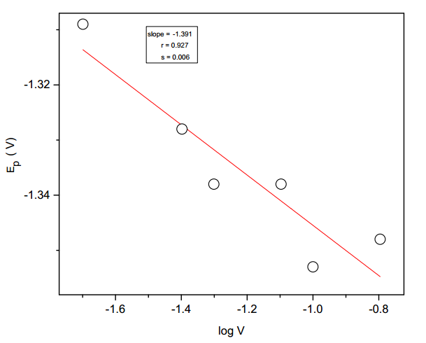

Fig.7. Plot of Ep of first peak versus log ν for the electrolytic reduction of (E)-1-

(furan-2-yl)-3-phenylprop-2-ene-1-ones in tetra butyl ammonium tetra fluoroborate.

Solvent = acetonitrile.